LANDART FESTIVAL

Malino, Croatia, 15.03. 2022.– 13.05.2022.

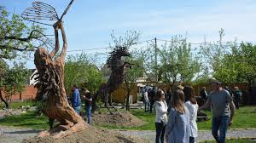

Information package
Dear partners and participants, here you will find all the important information about our project will take place soon in small charming place Malino, Croatia.

Please read all the information carefully!
Looking forward to see you soon

Lets start with information
WHAT: volunteer project
TITLE: Landart festival
PLACE: Malino, Croatia
APPLICANT: Arteco
www.arteco.hr

DATE: 15.03.2022 – 13.05.2022.

Who is target group of this project? (PARTICIPANTS)
Through the project "Landart festival" 10 young people will participate in volonteer project in Malino in the Municipality of Oriovac in BrodPosavina County.

Working language of volonteer project will be English (Your English doesn’t need to be perfect, neither is ours! Better a little English then no language communication at all.)

Main topic: creativity and culture, inclusion and art

The aim of the project is to make young people aware of the importance of diversity and its benefits, with the aim of increasing tolerance, solidarity and greater social inclusion and empowering positive initiatives. for initiative in your local community.
By empowering young people through the acquisition of competencies, tools, methods and skills, they will strengthen their self-confidence and sense of initiative and promote their common EU values in their local community.

Working methods and preparation for project

The project is organized from and for young people. Our activities during the preparation, implementation, evaluation and follow up phase ensure active participation of young people in each stage of the project. We want the project to make a positive change in the life of young participants and thus we value their reaction, opinion and feedback at every step of this project.
Working methods of this project are based on:
- active participation in workshops, presentations, study visits
- personal and group discussions
- brainstorming, and sessions for enhancing creativity
- personal development activities
- team-building activities, games (music, dance)
- intercultural dialogue and presentation

- art and creativity will be main method for teaching and developing skills

Financial condition (travel, accomodation)

Accomodation and food: 100% covered by Erasmus + Program
Travel costs: are budgeted according Erasmus + conditions (using the EU distance calculator).

Travel (ARRIVAL AND DEPARTURE)

The participants should arrive to Malino on 15.03.2022. and depart on 13.05..2022.
- You are invited to use most optimal and cheapest means of travel. If you choose to travel by plane, we recommend you to choose Zagreb airport.
- When you arrive to Zagreb airport you can use train that can get you directly to
Malino. In case that direct train to Malino does not fit your needs you can travel to
Nova Kapela and from there we will pick you up (It is just one stop from Malino)
- You can travel fro Zagreb by train to Slavonski Brod and that take another train to
Malino or to Nova Kapela
2. You can travel from Zagreb by bus – and go to Nova Gradiška or Slavonski Brod – from there you can use train to Malino or Nova Kapela, or you can just travel to Nova Gradiška or Slavonski Brod and we will pick you up – but you need to let us know your traveling agenda so that we can help you

- You can use near by airport in Budapest (Hungary), Belgrade (Serbia) and that from those destinations you can reach Slavonski Brod or Nova Gradiška

We kindly remind you that early accommodation and extra overstays will be your responsibility.

If you need assistence in order to plan your travel please let us know and we will help you.

Plese take in considiration that there is still COVID-19 pandemic and try to reach destination of project in most easy way – just to make things go more easy.

If you need assistence how to reach us you can always contact us by e-mail or by our phones:
- arteco.sb@gmail.com

- +385977670976 Zoran

Accomodation

When it comes to accomodation and your staying in Malino, we have prepared special conditions for your overall experiance. You will be hosted in our place that we have build – in sustainable, eco friendly, nutural houses.

We build this place with lot of love by respecting nature and with intention to offer part of fairytale in unique envirnoment. Everything that you will see there commes from our creative mind and it was created using materials that we could find in nature – and this is wery important for us. In that way we are 0 waste and envirnomental friendly robinson kind of people.

We higliht fact that our accomodation is robinson style of accomodation that tells story about how it is important to take care of nature, but also, what you can do with what nature can offer you.

Also, we understand that people nowdays live in modern technological society – our place is not like this. We will take you and bring you in fairytale – in place where you can find your inner peace and discover yourself again. (Ofcourse, we have water, electricity, internet, we are not far away from all things that you need: stores, hospitals, bars, train station, bus station and all other things that make us modern people – you will not felt isolated.)

In our accomodation we will offer you 3 mealns in a day and coffe breaks. When it comes to food – you will eat organic and local food prepared by us. Only the best that nature can offer you, we will bring to you and serve it with lots of love. Our accomodation and envirnoment will help in process of your personal development, and food will satisfy your personal needs.

We will take care of your needs and if you are vegan, vegeterian or omnivorus we will offey healthy and eco friendly (organic) food to you. If you have any special needs when it comes to food you will let us know in app form – and we will take care of it.

Also, you will need to bring towels with yourself :D – if you forget, we will help you, but take in mind that towels are your responsability.

Our adress: https://goo.gl/maps/BTukNnwg2iBv4rsi8

Here you can take a look about what we really are:
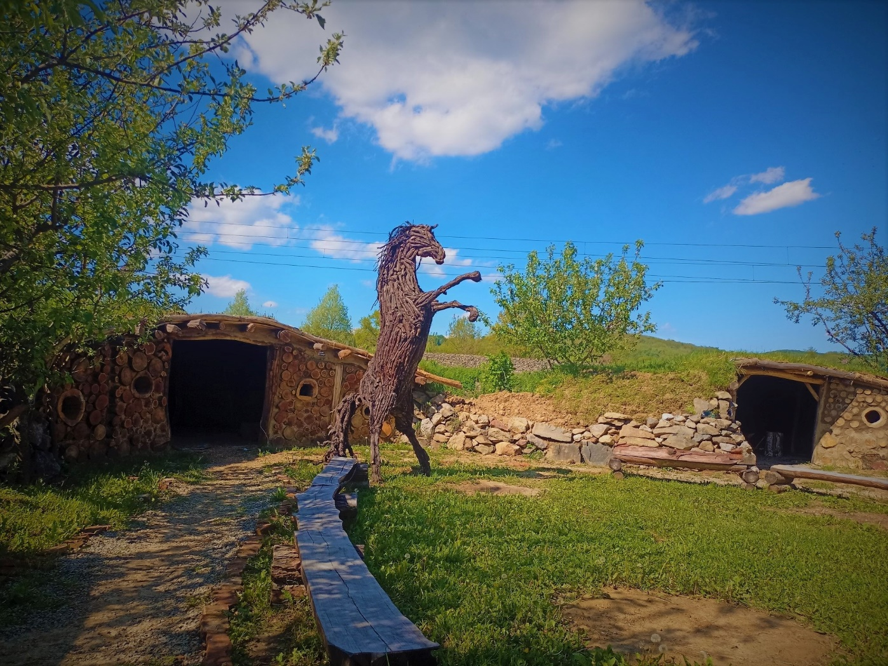

In Croatia you are obligatory to wear face masks in super markets and stores but also inside of every institution and every closed space, so bring face masks with you, medicine and other things for personal protection against COVID-19. Please
be responsible.

During the volunteer project, everyone will have the opportunity to present their own
country in a visual way at the Organizational Market Evening We encourage you to bring as much relevant material as possible.
Please bring your national food, traditional drinks, music or souvenirs for the intercultural evening. On this evening you will be able to show what is typical for your country; it can be food, drinks or whatever you would like to present from your country.

PROOF OF ALL THE TRAVEL EXPENSES
If you come by plane, please be sure to bring evidence of the sum actually paid (invoice) and boarding pass. Electronic tickets will only be considered as acceptable on proof of payment (invoice) and on presentation of the boarding pass for the outward journey. Please keep in mind the travel rules of the ERASMUS PLUS Program. If you come by train or bus do not forget to buy a return ticket. Please copy your tickets before you leave your home.

Documents needed for reimbursement of travel costs
Please take in count that ONLY THE TICKETS FOR BUSSES OR TRAINS ARE ALLOWED TO
BE PAID IN CASH. FOR THE AIRPLANE TICKETS YOU WILL HAVE TO PAY USING THE BANK SERVICES (ONLINE TRANSFER, PAYMENT ORDER, ETC.) EVEN YOU ARE BUYING THEM ONLINE OR DIRECTLY FROM THE AIRLINES COMPANY (OR ANOTHER TRAVEL AGENCY). During project you will also need to provide evidence that you paid your tickets that amount that you claim: if you buy tickets oline we will need bank transaction evidence, and if you pay by cash we need to have original bill with all information – we will check during project are your tickets ok

For reimbursement you will need
- An invoice for the tickets. - A receipt (showing that you have paind the money) – only for train and bus tickets;
- Printed document showing that money was payed (receipt, bank confirmation,
etc.)
- For the airplane tickets;

Please send us the prices of the tickets when you have them, so we could plan our budget.

Please note that we cannot reimburse travel costs if you lose your tickets or we do not receive all details and proofs of your expenses!

TRAVEL INSURANCE
It is necessary that all participants on this youth exchange have travel insurance. So buy travel insurance for the dates of this youth exchange. If you have EU health card please bring it with yourself.

PASSPORT
If you have a passport plese bring it.

If you need more information, please contact us at:

arteco.sb@gmail.com
+385977670976 Zoran

